DEEP LEARNING-BASED OBJECT DETECTION AND RECOGNITION FRAMEWORK FOR THE VISUALLY- IMPAIRED
A Mini project report submitted to
JNTU Hyderabad in partial fulfilment of the requirement for the award of the degree

BACHELOR OF TECHNOLOGY
In

CSE (ARTIFICIAL INTELLIGENCE AND MACHINE LEARNING)
Submitted by

VOOTKURI SATHVIKA REDDY 21S11A66H3 MASAGAARI MINNU R E D D Y 21S11A66F7 BAJJURI ANVESH 21S11A66D4
CHALLAMALLA SHARATH 21S11A66H4
Under the Guidance of

DR.A.NAGARAJU
M. Tech., Ph.D
Assistant Professor & Head of the Department CSE(AI&ML)

DEPARTMENT OF CSE (ARTIFICIAL INTELLIGENCE AND MACHINE LEARNING)

MALLA REDDY INSTITUTE OF TECHNOLOGY & SCIENCE
(Approved by AICTE New Delhi and Affliated to JNTUH) (Accredited by NBA & NAAC with “A” Grade)
An ISO 9001: 2015 Certifed Institution Maisammaguda, Medchal (M), Hyderabad-500100, T. S. MARCH 2024

DEPARTMENT OF CSE (ARTIFICIAL INTELLIGENCE & MACHINE LEARNING)

MALLA REDDY INSTITUTE OF TECHNOLOGY & SCIENCE
(Approved by AICTE New Delhi and Affliated to JNTUH) (Accredited by NBA & NAAC with “A” Grade)
An ISO 9001: 2015 Certifed Institution Maisammaguda, Medchal (M), Hyderabad-500100, T. S. MARCH 2024


CERTIFICATE

This is to certify that the mini project entitled “BDEEP LEARNING

-BASED OBJECT DETECTION AND RECOGNITION FRAMEWORK FOR THE
VISUALLY-IMPAIRED” has b e e n su b mi tte d b y VOOTKURI SATHVIKA REDDY(21S11A66H3), MASAGAARI MINNU REDDY(21S11A66F7),BAJJURI ANVESH
(21S11A66D4) and CHALLAMALLA SHARATH (21S11A66H4) in partial fulflment of the requirements for the award of BACHELOR OF TECHNOLOGY in CSE(AI&ML). This record of bonafde work carried out by them under my guidance and supervision.
The result embodied in this mini project report has not been submitted to any other University or Institute for the award of any degree.

DR.A.NAGARAJU Dr.A. NAGARAJU
Assistant professor & Head of theDepartment HOD of CSE(AI&ML) of CSE(AI&ML)
Project Guide
External Examiner

ACKNOWLEDGEMENT
The mini Project work carried out by our team in the Department of CSE(Artifcial intelligence and Machine Learning), Malla Reddy Institute of Technology and Science, Hyderabad. This work is original and has not been submitted in part or full for any degree or diploma of any other
university.

We wish to acknowledge our sincere thanks to our project guide DR.A.Nagaraju Assistant Professor & Head of the Department of CSE(AI&ML) for formulation of the problem, analysis, guidance and his continuous supervision during the course of work.
We acknowledge our sincere thanks to Dr. Vaka Murali Mohan, Principal and Dr. A. Nagaraju, Head of the Department and Coordinator, faculty members of CSE(AI&ML) Department for their kind cooperation in making this Project Stage II work a success.
We extend our gratitude to Sri. Ch. Malla Reddy, Founder Chairman MRGI and Sri. Ch. Mahender Reddy, Secretary MRGI, Dr.Ch. Bhadra Reddy, President MRGI, Sri. Ch. Shalini Reddy, Director MRGI, Sri. P. Praveen Reddy, Director MRGI, for their kind cooperation in providing the
infrastructure for completion of our Project Stage II.
We acknowledge our special thanks to the entire teaching faculty and non- teaching staff members of the CSE (Artifcial Intelligence and Machine Learning) Department for their support in making this project work a success.
[

VOOTKURI SATHVIKA REDDY 21S11A66H3 MASAGAARI MINNU REDDY 20S11A6653 BAJJURI ANVESH 20S11A6631 CHALLAMALLA SHARATH 20S11A6613

INDEX
Chapter Page No.
ABSTRACT vi
LIST OF FIGURES vii
- INTRODUCTION 1
- LITERATURE SURVEY 2
- SYSTEM ANNALYSIS 3
  - Existing system 3
    - Disadvantages of Existing System 4
  - Methodology 5
  - Proposed System 5
    - Advantages of Proposed System 6
- SYSTEM DESIGN 7
  - System Architecture 7
  - System Requirements 9
    - Hardware Requirements 9
    - Software Requirements 9
  - Functional Requirements 9
  - Non-Functional Requirements 10
  - System Implementation 11
    - Dataset 11
  - Unified Modeling Language Diagrams 13
    - Use Case Diagrams 16
    - Sequence Diagrams 19
  - Algorithms 24
    - SSD(Single Shot Detector) 24
    - CNN(Convolutional Nural Network) 25
- SOFTWARE ENVIRONMENT 28
  - Python 28
- SOURCE CODE 35
- SYSTEM TESTING 57
- RESULT 69
- CONCLUSION & FUTURE WORK 72
- BIBLIOGRAPHY 73

ABSTRACT

Vision impairment or blindness is one of the topten disabilities in humans, and unfortunately, India is home to the world’s largest visually impaired population. In this study, we present a novel framework to assist the visually impaired in object detection and recognition, so that they can independently navigate, and be aware of their surroundings. The paper employs transfer learning on Single-Shot Detection (SSD) mechanism for object detection and classification, followed by recognition of human faces and currency notes, if detected, using Inception v3 model. SSD detector is trained on modified PASCAL VOC 2007 dataset, in which a new class is added, to enable the detection of currency as well. Furthermore, separate Inception v3 models are trained to recognize human faces and currency notes, thus making the framework scalable and adaptable according to the user preferences. Ultimately, the output from the framework can then be presented to the visually impaired person in audio format. Mean Accuracy and Precision (mAP) scores of standalone SSD detector of the added currency class was 67.8 percent, and testing accuracy of person and currency recognition of Inception v3 model were 92.5 and 90.2 percent respectively. Index Terms—convolutional neural network, SSD, Inception v3, transfer learning

LIST OF FIGURES

Fig .No. | Fig. Name | Page No
Fig no.1 | System Architecture Flow Chart | 15
Fig no.2 | Use Case Diagram | 16
Fig no.3 | Sequential Diagram | 17
Fig no.4 | System Testing | 23
Fig no.5 | Result-I | 24
Fig no.6 | Result-II | 25

LIST OF TABLES

Table No | Table Name | Page No
T.No 1 | SSD 300 Training Parameters
T.No 2 | Human Face DataSet For Inception V3
T.No 3 | Currency Dataset for Inception V3

1. INTRODUCTION

Visually impaired people face a lot of difficulties in their lives. Recent statistics published by World Health Organization (WHO) in 2019 reveal that globally, around 2.2 billion individuals are affected by vision impairment. Detecting and recognizing common objects in the surroundings seem to be a herculean task for the visually impaired individuals. They rely either on other people, which makes the blind dependent on them, or, on their sense of touch and smell to detect objects, which is highly inaccurate and can be hazardous in some cases. The white cane is the most popular blind navigating device. This was further improved by adding ultrasonic and IR sensors to detect obstacles in the vicinity of the visually impaired user, and provide feedback in the form of vibration or sound. Though this approach was useful for the mobility of the visually impaired user, it provided little or no information about the surroundings. For the user to have a better understanding of the surrounding, objection detection and classification, followed by recognition and audio feedback is crucial. Neural networks, particularly, convolutional neural networks have shown promising results particularly in object detection, classification, and recognition tasks from images. In [1], the authors use a feed-forward neural network to provide speech suggestions regarding products of shopping. Real Time smartphone-based obstacle detection and classification system is implemented in [2]. The detection process involves interest point extraction and tracking through multiscale Lucas - Kanade algorithm, background motion estimation using homographic transforms and agglomerative clustering technique, followed by classification with the help of Histogram of Oriented Gradients (HOG) descriptor into Bag of Visual Words (BoVW). A survey on Electronic Travel Aids (ETA) designed for visually impaired navigation assistance is presented in [3]. Various ETAs, their strengths, and shortcomings are discussed and compared feature-wise. It also highlights the fact that no current system incorporates all necessary features and any technology should not attempt to replace the cane stick but to complement it by proper alerting and feedback. A deep novel architecture for visually impaired employing a late fusion of two parallel CNN’s outperforms the state-ofthe- art methods for activity recognition [4]. The two CNN’s GoogLeNet and AlexNet complement each other in identifying different features of the same class, hence the input video is fed to both of them, and the output class scores are combined using Support Vector Machine (SVM). Yet another novel method proposed in [5] uses CNN followed by a recurrent neural network (RNN) and softmax classifier for object detection,
and Hue, Saturation and Intensity (HSI) color thresholding for color recognition. An approach combining computer vision and deep learning techniques for visually impaired outdoor navigation assistant is shown in [6]. The system uses a regression-based mechanism for object tracking without a priori information, handles sudden camera movements, and exploits You Only Look Once (YOLO) for object recognition. A smartphone app is designed for guiding visually impaired persons in [7]. It can operate in two modes: online and offline based on user network connectivity. The online mode uses Faster RCNN to generate predictions in stable conditions and YOLO for faster results. Whereas, a feature recognition module using Haar features and Histogram of Gradients (HOG) serves this purpose in offline mode. A CNN is designed for pre-trained object recognition using the ImageNet dataset
[8]. A novel DLSNF (Deep-Learning-based Sensory Navigation Framework) built on the YOLO architecture is proposed in [9] for designing a sensory navigation device on top of NVIDIA Jetson TX2. SqeezeNet, a light-weight preProceedings of the Fourth International Conference on Computing Methodologies and Communication (ICCMC 2020)
IEEE Xplore Part Number:CFP20K25-ART; ISBN:978-1-7281-4889-2 978-1-7281-4889-
2/20/$31.00 ©2020 IEEE 725 .Authorized licensed use limited to: Fondren Library
Rice University. Downloaded on May 17,2020 at 12:09:17 UTC from IEEE Xplore.
Restrictions apply. 2020 Fourth International Conference on Computing Methodologies and Communication (ICCMC) 978-1-7281-4889-2/20/$31.00 ©2020 IEEE 10.1109/ICCMC48092.2020.ICCMC-000135Fig. 1. A schematic of the control flow diagram of the deep learning framework trained CNN model, achieved better performance and reduced computational latency per image [10]. SqueezeNet is improved by changing the weights of the last convolutional layer, replacing the Rectified Linear Unit (ReLU) with LeakyReLU as activation function and addition of batch normalization layer. In this study, we propose a deep learning framework for image detection, classification and person-currency recognition. As per the authors’ knowledge, no other work has integrated person and currency recognition in addition to object detection and classification for assisting the visually impaired. The input can be taken from a camera. Transfer learning is performed on the SSD - VGG16 model to predict classes of the PASCAL VOC 2007 dataset. In addition to the existing 20 classes in PASCAL VOC 2007, we add new images in the dataset incorporating currency class also, making the total predictable classes to be 21.

The detected object classes are produced in the output. Also, if the detected category is either person or currency, the cropped image of the bounding box of the detected class is fed as an input to separate Inception v3 models.

The Inception v3 model is trained using transfer learning using ImageNet weights.
The system is currently trained to recognize 5 human faces and 6 currency note types and can be modified as per user requirements, making this approach modular, scalable and user-friendly. The paper is organized as follows. Section II provides details about the proposed design of our deep neural network framework. Section III describes the training details. The results are presented in section IV. Section V gives an insight into the possible future extensions and finally, concludes this paper.

2. LITERATURE SURVEY

In order to create an object detection model, it is very much necessary to inculcate machine learning techniques. We need to create certain data models for the computer system to detect the objects. In order to achieve , we need to capture labelled images of certain classes and store it in individual datasets. Larger the data set, the greater is the accuracy of the trained model, which is very much mandatory to achieve better object detection. Deep learning techniques such as Convolutional Neural Networks (CNN) are being used for object detection as shown in figure 1, are used on a large scale nowadays. [1] The Convolutional Neural networks consist of multi- layered architecture including an input layer, many hidden layers and an output layer. The image is extracted from the video and given to the input layer. In general, the hidden layers in a CNN operate as filters, receiving input from the higher layer, processing it with a certain pattern or feature, and then sending it to the next layer. The output layer classifies the image based on the input from the hidden convolutional layers.

3. SYSTEM ANALYSIS

3.1 EXISTING SYSTEM
In the present world, there are many computer vision systems to help the visually impaired in various stages of their life. These mainly include AI and GPS based navigation systems, Wearable Goggles for visually impaired based on Augmented Reality, video calling apps for the visually impaired to ask for assistance and many other technologies. These systems are built to work only in specific cases or conditions, and cannot be used on a large scale. There are cases wherein the people with visual impairment have to realize about their surroundings, which is not easily possible with the existing systems.

3.1.1 Disadvantages of Existing System:
- They are expensive which makes it difficult for the visually impaired people to afford it.
- These systems have functionality which is very complex, making it difficult to be used by the visually impaired.
- No personalised user experience and the systems are not real-time.

3.2 METHODOLOGY
In this project we are combining SSD300 (single shot detector) with inception model to detect and recognized CURRENCY NOTES. SSD is capable of recognizing 21 classes but will not recognized currency notes so we have added extra layer with extra class to detect currency notes but its accuracy is not good so we extracted features from SSD and then retrained with INCEPTIONV3 which is able to get accuracy more than 98%.
For currency detection we have used INDIAN OLD NOTES dataset as new currency notes dataset not available so we trained SSD and inception with OLD currency notes and then this new model can detect total 21 classes with 1 more class as currency so now SSD can detect and recognized total 22 classes.
To implement this project we have designed following module
Generate SSD-Inception Model: using this module we will generate and load SSD300 and inception model
Run SSD300 Object Detection & Classification: using this model we will detect and classify object (21 classes with currency) using SSD and Inception model
Inception Accuracy & Loss Graph: using this module we will plot Inception training accuracy and loss graph.

3.3 PROPOSED SYSTEM

The proposed system consists of four subparts namely, the camera for inputting the image into the framework, object detection and classification module, the face and currency recognition modules, and finally, audio output to the visually impaired user as shown in Fig.
- In this work, we focus on the design of the framework, which involves object detection, classification and recognition. SSD has shown faster single shot detection results for multiple categories [11]. PASCAL VOC 2007 dataset [12] has 20 classes of objects, containing 9,963 images having 24,640 annotated objects. This dataset was modified by
adding more images in the training, validation and testing sets, making the total classes to 21, the new class being currency. This modified PASCAL VOC 2007 dataset is trained using transfer learning on SSD model. Input image is resized to 300 by 300 pixels. SSD300 model was initially loaded with weights from VGG-16 model. The framework makes a bounding box around any of the trained 21 categories if it exists in the input image. Intersection over Union (IoU) method shown in Fig. 2 is used to evaluate the performance. The name of any category other than human or currency, if detected, is fed into audio output. For human or currency classes, one more stage is required which is the recognition part.

3.3.1 Advantages of Proposed System:
  - Detects objects quickly and specifies the object type which helps to avoid obstacles.
  - Can be used at any place and any time irrespective of the weather conditions and locations.
  - Informs the user about the object without getting close to the object.
  - Decreases the public interference wanting to assit.

4. SYSTEM DESIGN

Next step is to bring down whole knowledge of requirements and analysis on the desk and design the software product. The inputs from users and information gathered in requirement gathering phase are the inputs of this step. The output of this step comes in the form of two designs; logical design and physical design. Engineers produce meta-data and data dictionaries, logical diagrams, data-flow diagrams and in some cases pseudo codes.

4.1 System Architecture
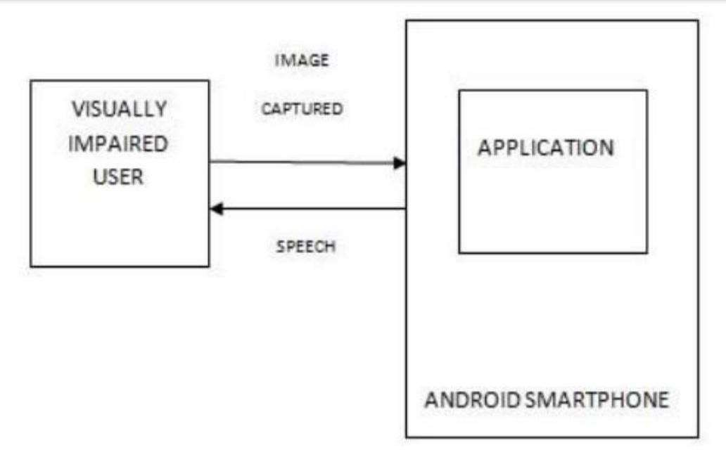

Fig No: 1 System Architecture

4.2 SYSTEM REQUIREMENTS:

4.2.1 Hardward Requirements:

    - Processor : Intel i3 and above
    - Ram : 4GB and Higher
    - Hard Disk : 500GB: Minimum

4.2.2 Software Requirements:
    - Programming Language : Python
    - UML Design : Start UML
    - Tools : PIP
    - Web Server : WSGI
    - Framework : DJango

4.3 Functional Requirements

Model Generation:
  - The system shall load the SSD300 and Inception models when the 'Generate SSD - Inception Model' button is clicked.
  - The system shall confirm the successful loading of models with a visual indicator (e.g., red text).

Object Detection and Classification:
  - The system shall allow users to upload images for object detection.
  - The system shall use the SSD300 and Inception models to detect and classify objects within the uploaded images.
  - The system shall support detection and classification of 22 classes (21 predefined classes plus currency notes).
  - The system shall display detected objects along with their classifications in the image.

Inception Accuracy & Loss Graph:
  - The system shall plot the accuracy and loss graph for Inception training over 15 epochs.
  - The system shall use the x-axis to represent epochs and the y-axis to represent accuracy and loss values.
  - The system shall display the accuracy as a green line and the loss as a red line on the graph.

User Interface:
  - The system shall provide a user interface with buttons to generate models, run object detection, and display the accuracy and loss graph.
  - The system shall allow users to double-click the ‘run.bat’ file to launch the application.

4.4 Non-Functional Requirements

Performance:
  - The system shall achieve an accuracy of over 98% for currency note detection.
  - The system shall load models within a reasonable time frame (e.g., under 30 seconds).
  - The system shall process and classify images quickly, with a response time of under 5 seconds per image.

Usability:
  - The system shall have an intuitive and user-friendly interface, making it easy for users to upload images and view results.
  - The system shall provide clear and readable feedback on actions, such as model loading status and detected objects.

Reliability:
  - The system shall reliably detect and classify objects in various images.
  - The system shall handle different image formats (e.g., JPG, PNG) without crashing.

Scalability:
  - The system shall be scalable to accommodate additional classes in the future without significant reengineering.

Maintainability:
  - The system shall be designed in a modular way to facilitate updates and maintenance.
  - The system's code shall be well-documented to assist developers in future modifications.

Security:
  - The system shall ensure that uploaded images are handled securely, with appropriate measures to prevent unauthorized access or data breaches.
  - The system shall not retain user-uploaded images after processing to protect user privacy.

Compatibility:
  - The system shall be compatible with standard operating systems (e.g., Windows, macOS, Linux).
  - The system shall require minimal dependencies and be easy to set up on different machines.

4.5 SYSTEM IMPLEMENTATION:

In the initial we created a React Application in order to build the front-end of our Application or in other words the User Application(UI). In order to get In the object detection , we used TensorFlow module and imported the required modules into our project. In the next step, we created a promise to get the detection as a promise and we created a rectangular box around the detected object. After getting the detections , we used the SpeechSynthesisUtterence to generate the audio results. This Web Speech API interface represents a speech request. It contains the content the speech service should read and information about how to read it. To get the audio results , we create an array containing the detections and pass the class in the speech synthesizer in order to generate the audio voice alert to assist the visually impaired.

4.5.1 Data Set:
Intel Core i5 CPU with 8 GB RAM and GTX 1050 Ti as the GPU was used for transfer learning on SSD300 and Inception v3 model, with Tensorflow and Keras library, coded in Python.
Annotated images for 20 classes were available in the PASCAL VOC 2007 dataset. For the new class currency that we added, LabelImg Master [17] was used for generating annotations, and bounding box creations in VOC 2007 format. Fig. 4 shows a sample annotation generated by LabelImg for an image containing the currency class. Rest of the simulation parameters are listed in table I, II, III.

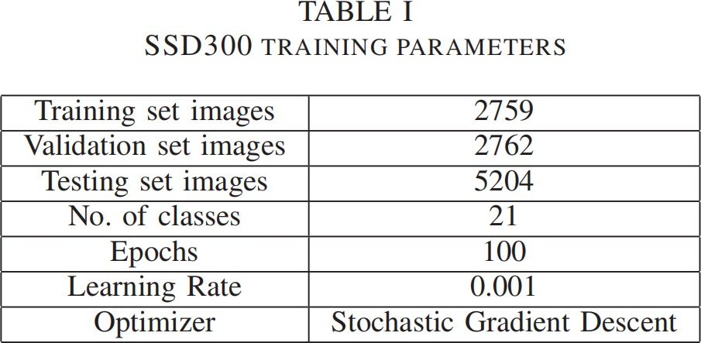
T.No:1 SSD 300 Training Parameters
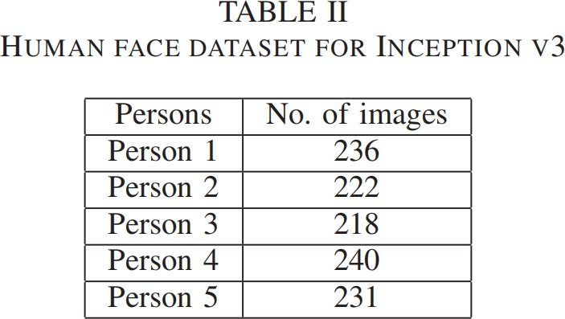

T.No:2 Human Face DataSet For Inception V3

of 67.8 percent on the added currency class. This shows the model is trained successfully to recognize and classify currency class in addition to 20 other classes in the dataset. The cropped images of the classified human and currency can then be fed to separate Inception v3 models trained for the purpose. Inception v3 model trained on the person dataset achieved a testing accuracy of 92.5 percent and that tr ained on currency dataset achieved 90.2 percent.


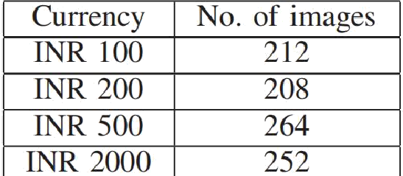
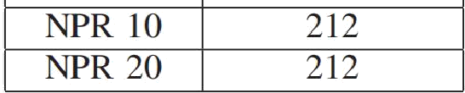

T.No:3 Currency Dataset for Inception V3

4.6 UNIFIED MODELING LANGUAGE DIAGRAMS:

Unified Modeling Language (UML) is a general purpose modeling language. The main aim of UML is to define a standard way to visualize the way a system has been designed. It is quite similar to blueprints used in other fields of engineering.
UML is not a programming language; it is rather a visual language. We use UML diagrams to portray the behavior and structure of a system, UML helps software engineers, businessmen and system architects with modeling, design and analysis. The Object Management Group (OMG) adopted Unified Modeling Language as a standard in 1997. It’s been managed by OMG ever since. International Organization for Standardization (ISO) published UML as an approved standard in 2005. UML has been revised over the years and is reviewed periodically.

4.6.1 Use Case Diagram

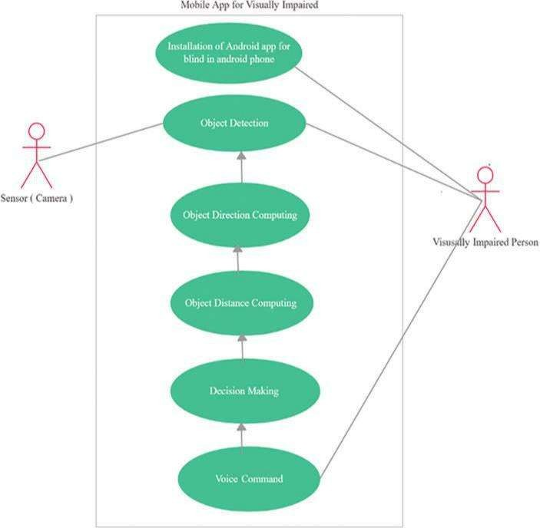

Fig No: 2 Use Case Diagram

A use case diagram in the Unified Modeling Language (UML) is a type of behavioral diagram defined by and created from a Use-case analysis. Its purpose is to present a graphical overview of the functionality provided by a system in terms of actors, their goals (represented as use cases), and any dependencies between those use cases. The main purpose of a use case diagram is to show what system functions are performed for which actor. Roles of the actors in the system can be depicted.

4.6.2 Sequence Diagram:
A sequence diagram in Unified Modeling Language (UML) is a kind of interaction diagram that shows how processes operate with one another and in what order. It is a construct of a Message Sequence Chart. Sequence diagrams are sometimes called event diagrams, event scenarios, and timing diagrams.

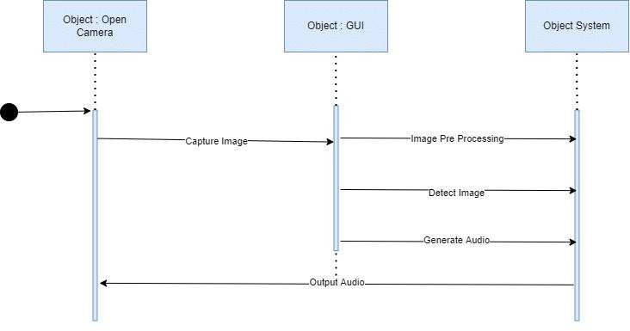

Fig No: 3 Sequence Diagram

4.7 ALGORITHM

4.7.1 SSD(Single shot detector):
SSD Algorithm is used for the object recognition as well as detection. Also this algorithm gives nearly accurate results for real time object detection and is proven to be faster than other relative algorithms.
- SSD takes only one shot to detect multiple objects present in an image using multibox.
- There exist 2 sections for an object detection system using SSD algorithm.
- One is to extract the feature maps
- Second is to apply filters of convolution to detect objects.

4.7.2 CONVOLUTIONAL NEURAL NETWORK(CNN) :

  - CNN is a neural network with multiple layers. It is a class of Deep Neural Network that is mostly used for the purpose of analysis of visual images.
  - CNN contains one layer for input, called as input layer, next it has one or more middle layers which are called as convolutional layers, next the network consists of one or more fully connected layers and lastly the network is completed by adding an output layer in the respective order.

5. SOFTWARE ENVIRONMENT

5.1 Python

The Python programming language is an Open Source, cross-platform, high level, dynamic, interpreted language . The Python 'philosophy' emphasizes readability, clarity and simplicity, whilst maximizing the power and expressiveness available to the programmer. The ultimate compliment to a Python programmer is not that his code is clever, but that it is elegant. For these reasons Python is an excellent 'first language', while still being a powerful tool in the hands of the seasoned and cynical programmer.

Python is a very flexible language. It is widely used for many different purposes. Typical uses include :
    - Web application programming with frameworks like Zope, Django and Turbo gears
    - System administration tasks via simple scripts
    - Desktop applications using GUI toolkits like Tkinter or wxPython (and recently Windows Forms and Iron Python)
    - Creating windows applications, using the Pywin32 extension for full windows integration and possibly Py2exe to create standalone programs
    - Scientific research using packages like Scipy and Matplotlib

Good to Know

    - The most recent major version of Python is Python 3, which we shall be using in this tutorial. However, Python 2, although not being updated with anything other than security updates, is still quite popular.
    - In this tutorial Python will be written in a text editor. It is possible to write Python in an Integrated Development Environment, such as Thonny, Py charm, Net beans or Eclipse which are particularly useful when managing larger collections of Python files.

Python Syntax compared to other programming languages

    - Python was designed for readability, and has some similarities to the English language with influence from mathematics.
    - Python uses new lines to complete a command, as opposed to other programming languages which often use semicolons or parentheses.
    - Python relies on indentation, using whitespace, to define scope; such as the scope of loops, functions and classes. Other programming languages often use curly-brackets for this purpose.

Python libraries for Machine Learning
Deep Learning Libraries:

TensorFlow is a very popular open-source library for high performance numerical computation developed by the Google Brain team in Google. As the name suggests, Tensorflow is a framework that involves defining and running computations involving tensors. It can train and run deep neural networks that can be used to develop several AI applications. TensorFlow is widely used in the field of deep learning research and application.
Keras is a very popular Machine Learning library for Python. It is a high-level neural networks API capable of running on top of TensorFlow, CNTK, or Theano. It can run seamlessly on both CPU and GPU. Keras makes it really for ML beginners to build and design a Neural Network. One of the best thing about Keras is that it allows for easy and fast prototyping.
PyTorch is a popular open-source Machine Learning library for Python based on Torch, which is an open-source Machine Learning library which is implemented in C with a wrapper in Lua. It has an extensive choice of tools and libraries that supports on Computer Vision, Natural Language Processing (NLP) and many more ML programs.

It allows developers to perform computations on Tensors with GPU acceleration and also helps in creating computational graphs.
fastai is a deep learning library that provides high-level components which can quickly and easily provide state-of-the-art results in standard deep learning domains. It also provides researchers with low-level components that can be mixed and matched to build new approaches. fastai includes various features, such as a GPU-optimised computer vision library which can be extended in pure Python, a new type dispatch system for Python along with a semantic type hierarchy for Imutils is a computer vision package that includes a series of OpenCV + convenience functions to make basic image processing functions such as translation, rotation, resizing, skeletonisation, displaying Matplotlib images, sorting contours, detecting edges, among others quite easy.OpenCV is a popular and open-source computer
vision library that is focussed on real-time applications. The library has a modular structure and includes several hundreds of computer vision algorithms. OpenCV includes a number of modules including image processing, video analysis, 2D feature framework, object detection, camera calibration, 3D reconstruction and more. Pytessarct or Python-tesseract is an optical character recognition (OCR) tool for the Python language. This tool is a wrapper for Google’s Tesseract-OCR Engine and helps in recognising and reading the text embedded in an image.Pickle module is used for serializing and de-serializing a Python object structure. Any object in Python can be pickled so that it can be saved on disk. What pickle does is that it “serializes” the object first before writing it to file. Pickling is a way to convert a python object (list, dict, etc.) into a character stream. The idea is that this character stream contains all the information necessary to reconstruct the object in another python script.

6. SOURCE CODE

import os import cv2
import numpy as np

from keras.utils.np_utils import to_categorical from keras.layers import MaxPooling2D
from keras.layers import Dense, Dropout, Activation, Flatten from keras.layers import Convolution2D from keras.models import Sequential
from keras.models import model_from_json import pickle
from keras.applications.inception_v3 import InceptionV3

# Non-Binary Image Classification using Convolution Neural Networks '''
class_labels = ['fifty', 'fivehundred', 'hundred', 'ten', 'thousand', 'twenty']

path = 'Dataset'

labels = [] X=[]
Y=[]

def getID(name):

index = 0

for i in range(len(labels)): if labels[i] == name:
index = i break
return index

for root, dirs, directory in os.walk(path): for j in range(len(directory)):
name = os.path.basename(root) if name not in labels:
labels.append(name) print(labels)

for root, dirs, directory in os.walk(path): for j in range(len(directory)):
name = os.path.basename(root) print(name+" "+root+"/"+directory[j]) if 'Thumbs.db' not in directory[j]:
img = cv2.imread(root+"/"+directory[j])

img = cv2.resize(img, (32,32))

im2arr = np.array(img)

im2arr = im2arr.reshape(32,32,3) X.append(im2arr) Y.append(getID(name))

X = np.asarray(X) Y = np.asarray(Y) print(Y)

np.save('model/X.txt',X) np.save('model/Y.txt',Y) '''
X = np.load('model/X.txt.npy') Y = np.load('model/Y.txt.npy')

X = X.astype('float32')

X = X/255

test = X[3] cv2.imshow("aa",test) cv2.waitKey(0)
indices = np.arange(X.shape[0]) np.random.shuffle(indices)
X = X[indices]

Y = Y[indices]

Y = to_categorical(Y)

print(Y)

if os.path.exists('model/model.json'):

with open('model/model.json', "r") as json_file: loaded_model_json = json_file.read()
classifier = model_from_json(loaded_model_json) json_file.close() classifier.load_weights("model/model_weights.h5") classifier._make_predict_function()
else:

inception = InceptionV3(input_shape = (75, 75, 3), include_top = False, weights = 'imagenet')
inception.trainable = False classifier = Sequential() classifier.add(inception)
classifier.add(Convolution2D(32, 3, 3, input_shape = (32, 32, 3), activation = 'relu'))

classifier.add(MaxPooling2D(pool_size = (2, 2)))

classifier.add(Convolution2D(32, 3, 3, activation = 'relu'))

classifier.add(MaxPooling2D(pool_size = (2, 2))) classifier.add(Flatten())
classifier.add(Dense(output_dim = 256, activation = 'relu')) classifier.add(Dense(output_dim = Y.shape[1], activation = 'softmax')) print(classifier.summary())

classifier.compile(optimizer = 'adam', loss = 'categorical_crossentropy', metrics = ['accuracy'])
hist = classifier.fit(X, Y, batch_size=16, epochs=15, shuffle=True, verbose=2) classifier.save_weights('model/model_weights.h5')
model_json = classifier.to_json()

with open("model/model.json", "w") as json_file: json_file.write(model_json)
f = open('model/history.pckl', 'wb') pickle.dump(hist.history, f) f.close()
f = open('model/history.pckl', 'rb') data = pickle.load(f)
f.close()

acc = data['accuracy'] accuracy = acc[9] * 100
print("Training Model Accuracy = "+str(accuracy))

7. SYSTEM TESTING

The Indian currency dataset used for training one of the Inception v3 model, and for SSD300 currency class was designed by us. Four human faces in dataset for the other Inception v3 model were taken from Labelled Faces in the Wild (LFW) [14], along with one human face category with 240 images added by us. Various works implemented neural networks for currency recognition [15], [16], however, there is a lack of an all in one framework combining common classes classification, human faces and currency recognition, which is achieved in this work.

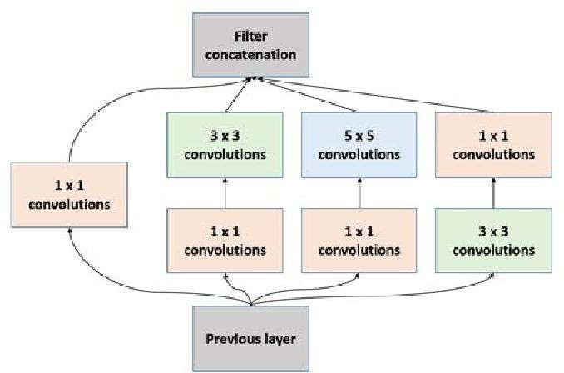

Fig No:4 System Testing

8. RESULT

The project successfully developed a deep learning-based framework to assist visually- impaired individuals in detecting and recognizing objects, including currency notes, by combining the SSD300 (Single Shot Multibox Detector) with the InceptionV3 model.
Initially, SSD300, which recognizes 21 object classes, was extended to detect currency notes by adding an extra layer, but the accuracy was insufficient. To address this, features from SSD300 were retrained using InceptionV3, resulting in over 98% accuracy. Using the Indian Old Notes dataset, the new model can now detect 22 classes, including currency notes. The project involved generating and loading the combined models, detecting and classifying objects through image uploads, and plotting training accuracy and loss graphs. Training the InceptionV3 model over 15 epochs demonstrated increased accuracy and decreased loss, ultimately achieving 100% accuracy and zero loss, proving the model's efficacy in object and currency note recognition.



Fig No:5 Result-I

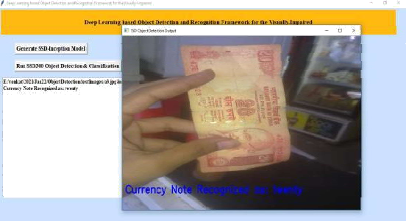

Fig No:6 Result-II.

9. CONCLUSION & FUTURE SCOPE

A novel framework employing object detection, classification, and face and currency recognition has been presented to assist the visually impaired people. It is fairly simple, and easy to deploy, once the training part is complete. Using separate Inception models for faces and currency recognition makes it faster, user-specific and adaptable. It is one of the most generic Proceedings of the Fourth International Conference on Computing Methodologies and Communication (ICCMC 2020) IEEE Xplore Part Number:CFP20K25-ART; ISBN:978- 1-7281-4889-2 978-1-7281-4889-2/20/$31.00 ©2020 IEEE 727 Authorized licensed use limited to: Fondren Library Rice University. Downloaded on May 17,2020 at 12:09:17 UTC from IEEE Xplore. Restrictions apply. Proceedings of the Fourth International Conference on Computing Methodologies and Communication (ICCMC 2020) IEEE Xplore Part Number:CFP20K25-ART; ISBN:978-1-7281-4889-2 framework, integrating all the useful features, and will surely prove to be a great service to mankind. Future work can be done to make the face and currency recognition spoof-proof.

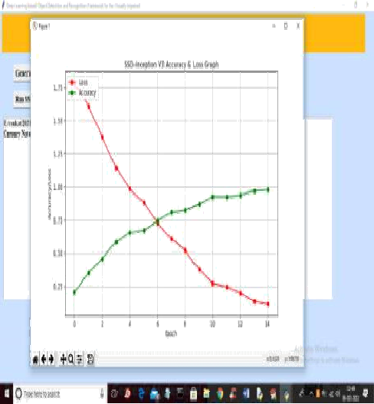

Fig No:7 Result-III

10. BIBLIOGRAPHY

Computing and Communications; IEEE 16th International Conference on Smart City; IEEE 4th International Conference on Data Science and Systems (HPCC/SmartCity/DSS). IEEE, 2018, pp. 1195–1200. [10] H. Alhichri, Y. Bazi, N. Alajlan, and B. Bin Jdira, “Helping the visually impaired see via image multi-labeling based on squeezenet cnn,” Applied Sciences, vol. 9, no. 21, p. 4656, 2019. [11] W. Liu, D. Anguelov, D. Erhan, C. Szegedy, S. Reed, C.-Y. Fu, and A. C. Berg, “Ssd: Single shot multibox detector,” in European conference on computer vision. Springer, 2016, pp. 21–37. [12] M. Everingham, L. Van Gool, C. K. I. Williams, J. Winn, and A. Zisserman, “The PASCAL Visual Object Classes
Challenge 2007 (VOC2007)Results,”http://www.pascalnetwork.org/challenges/VOC/voc2007/workshop/inde x.html. [1] F. Jabeen, A. Muhammad, and A. M. Enriquez, “Feed forward neural network training based interactive shopping for blind,” in 2015 12th International Conference on Electrical Engineering, Computing Science and Automatic Control (CCE). IEEE, 2015, pp. 1–6.

- R. Tapu, B. Mocanu, A. Bursuc, and T. Zaharia, “A smartphonebased obstacle detection and classification system for assisting visually impaired people,” in Proceedings of the IEEE International Conference on Computer Vision Workshops, 2013, pp. 444–451.
- R. Tapu, B. Mocanu, and E. Tapu, “A survey on wearable devices used to assist the visual impaired user navigation in outdoor environments,” in 2014 11th international symposium on electronics
and telecommuni cations (ISETC). IEEE, 2014, pp. 1–4.
- J. Monteiro, J. P. Aires, R. Granada, R. C. Barros, and F. Meneguzzi, “Virtual guide dog: An application to support visually-impaired people through deep convolutional neural networks,” in 2017 International Joint Conference on Neural Networks (IJCNN). IEEE, 2017,
pp. 2267–2274.
- R. Kumar and S. Meher, “A novel method for visually impaired using object recognition,” in 2015 International Conference on Communications and Signal Processing (ICCSP). IEEE, 2015, pp. 0772–0776.
- R. Tapu, B. Mocanu, and T. Zaharia, “Seeing without sight-an automatic cognition system dedicated to blind and visually impaired people,” in Proceedings of the IEEE International Conference on Computer Vision Workshops, 2017, pp. 1452–1459.

- B.-S. Lin, C.-C. Lee, and P.-Y. Chiang, “Simple smartphone-based guiding system for visually impaired people,” Sensors, vol. 17, no. 6, p. 1371, 2017.
- K. Potdar, C. D. Pai, and S. Akolkar, “A convolutional neural network based live object recognition system as blind aid,” arXiv preprint arXiv:1811.10399, 2018.
- J.-C. Ying, C.-Y. Li, G.-W. Wu, J.-X. Li, W.-J. Chen, and D.-L. Yang, “A deep
learning approach to sensory navigation device for blind guidance,” in 2018 IEEE 20th International Conference on High Performance
- H. Alhichri, Y. Bazi, N. Alajlan, and B. Bin Jdira, “Helping the visually impaired see
via image multi-labeling based on squeezenet cnn,” Applied Sciences, vol. 9, no. 21, p. 4656, 2019.
- W. Liu, D. Anguelov, D. Erhan, C. Szegedy, S. Reed, C.-Y. Fu, and A. C. Berg, “Ssd: Single shot multibox detector,” in European conference on computer vision. Springer, 2016,
pp. 21–37.
- M. Everingham, L. Van Gool, C. K. I. Williams, J. Winn, and A. Zisserman, “The PASCAL Visual Object Classes Challenge 2007 (VOC2007) Results,” http://www.pascal network.org/challenges/VOC/voc2007/workshop/index.html.
- C. Szegedy, V. Vanhoucke, S. Ioffe, J. Shlens, and Z. Wojna, “Rethinking the inception architecture for computer vision,” in Proceedings of the IEEE conference on computer vision and pattern recognition, 2016, pp. 2818–2826.
- G. B. Huang, M. Mattar, H. Lee, and E. Learned-Miller, “Learning to align from scratch,” in NIPS, 2012.
- N. A. Semary, S. M. Fadl, M. S. Essa, and A. F. Gad, “Currency recognition system for visually impaired: Egyptian banknote as a study case,” in 2015 5th International Conference on Information & Communication Technology and Accessibility (ICTA). IEEE, 2015, pp.
1.6.
- S. Singh, S. Choudhury, K. Vishal, and C. Jawahar, “Currency recognition on mobile phones,” in 2014 22nd International Conference on Pattern Recognition. IEEE, 2014, pp. 2661–2666.
- Tzutalin, LabelImg. Git code (2015), 2015. [Online]. Available:https://github.com/tzutalin/labelImg

